**Ideation Phase**

**Empathize & Discover**

|  |  |
| --- | --- |
| Date | 26/06/2025 |
| Team ID | LTVIP2025TMID33042 |
| Project Name | HematoVision-Blood Cell Classifier |
| Maximum Marks | 4 Marks |

**Section Overview** An Empathy Map helps us step into our user’s shoes—understanding what they say, think, do, and feel—so HematoVision really addresses their core needs.

**Empathy Chart**

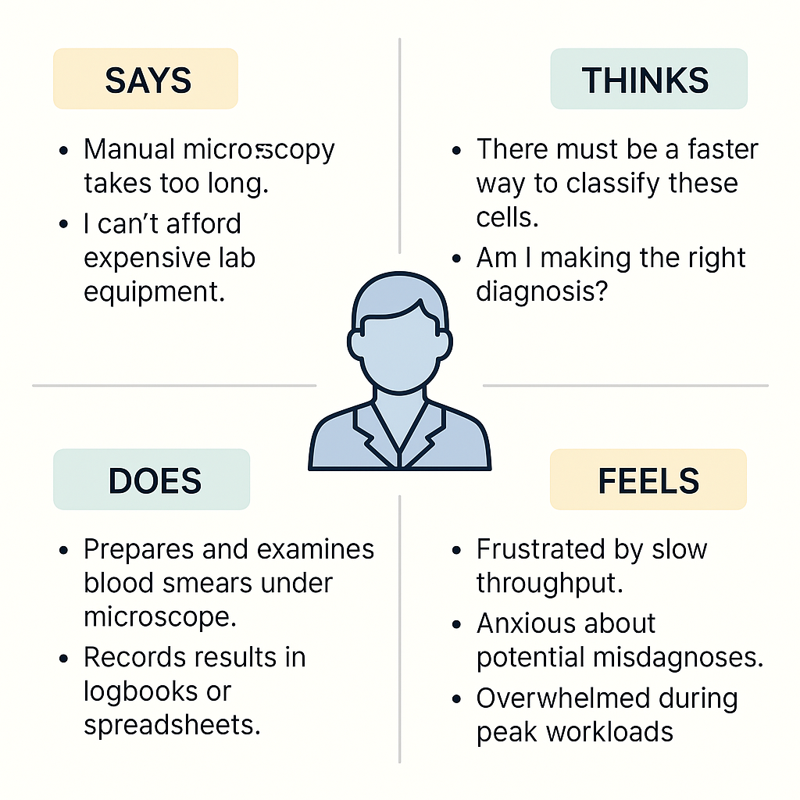

|  | **Complaints by the customers** |
| --- | --- |
| **Says** | • “Manual microscopy takes too long  • “I can’t afford expensive lab equipment.” |
| **Thinks** | • “There must be a faster way to classify these cells  • “Am I making the right diagnosis?” |
| **Does** | • Prepares and examines blood smears under microscope  • Records results in logbooks or spreadsheets  • Requests second opinions when unsure. |
| **Feels** | • Frustrated by slow throughput  • Anxious about potential misdiagnoses  • Overwhelmed during peak workloads. |